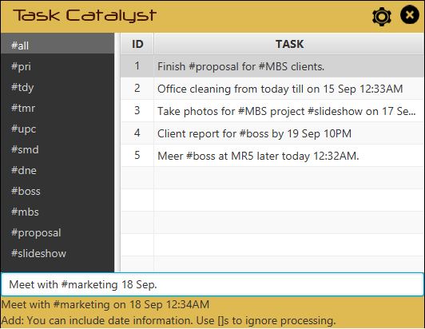
Task Catalyst

Supervisor: Yeow Kai Yao Extra feature: Natural Bucket
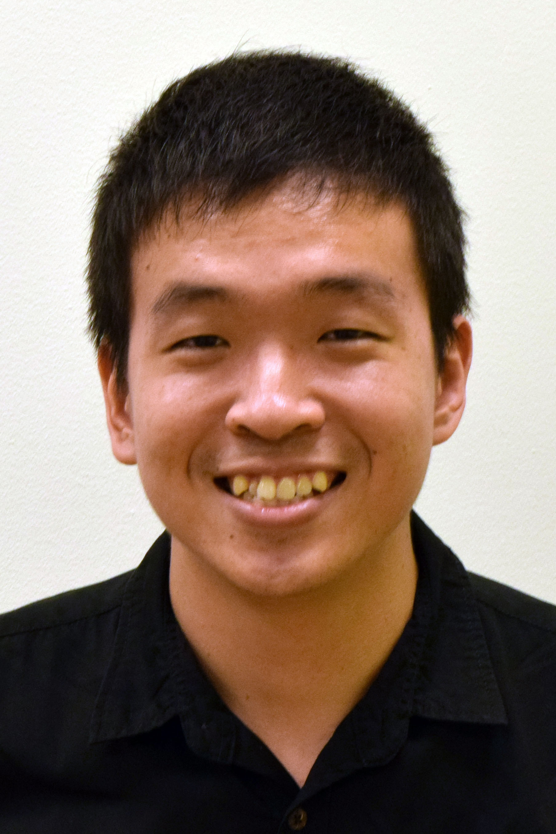  Ang Kah Min, Kelvin  Project Team Leader  Code Quality  Integration  Testing |   Toh Zhen Yu  CS2101 Team leader  Documentation  Code Quality  Testing |   Lin XiuQing, Thida  Scheduling and Tracking  Resource Acquisition  Testing  Integration |   Lim Wei Jie  Testing  Code Quality  Resource Acquisition  Integration

Vision
Task Catalyst is a lightweight and simple task manager that aims to provide a natural user experience, serving as a catalyst between the user and their tasks.
Audience
Task Catalyst caters to the modern urban crowd with a busy lifestyle. The program is optimized for keyboard-use, and hence provides for many command styles (UNIX, DOS, plain English, etc.) and uses familiar features like hashtagging for organization.
User guide

Main Interface

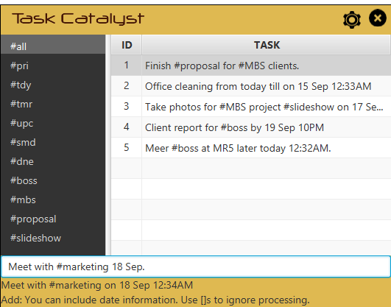
Task View
Command
Bar
Default Hashtags
Hashtags
User Hashtags
Hashtags
Status and Help Bar
Hashtags
Settings and Exit button
Hashtags
The Settings Button will launch the settings window and the Exit Button will close the program.
The Task View is where tasks are displayed. It changes accordingly to category, hashtags and search term.

The Command Bar is where commands are entered. It is the main mode of operating the software.

The Default Hashtags contain categories that tasks are grouped into by default. Below is an explanation of what they mean:
#all – All Tasks
#pri – Priority Tasks
#tdy – Today’s Tasks
#tmr – Tomorrow’s Tasks
#upc – Upcoming Tasks
#smd – Someday Tasks
#dne – Done Tasks

The User Hashtags section displays hashtags used by the user when adding tasks. They can be quickly used to organize tasks.
The Status and Help Bar displays helpful context-sensitive hints and status messages.

Adding a Task
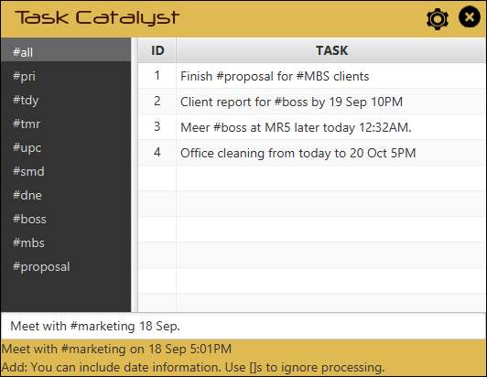
Adding a task is as simple as typing it into the command bar. You do not have to follow strict formats as the program naturally understands date and time.

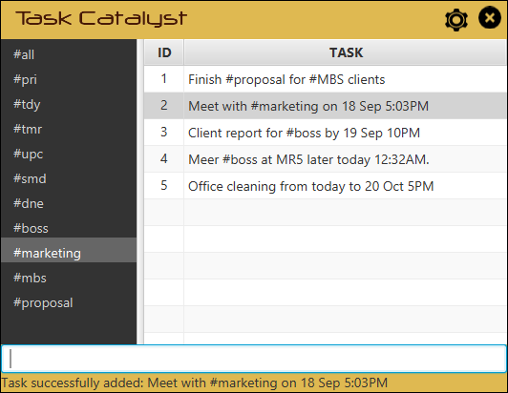
You can make use of the hashtagging feature to organize your tasks. When hashtags are specified, they appear in the hashtag list at the left.

Working with Hashtags
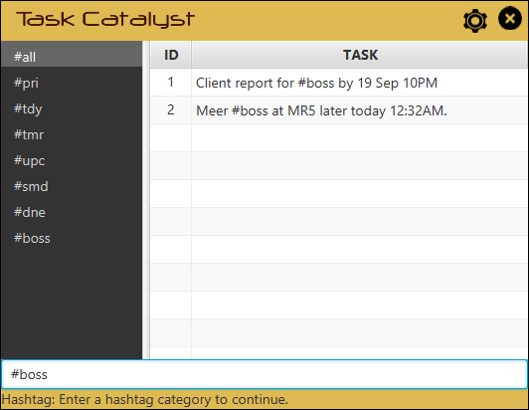
You can quickly navigate through categories or custom hashtags simply by typing the hashtag in the command bar.

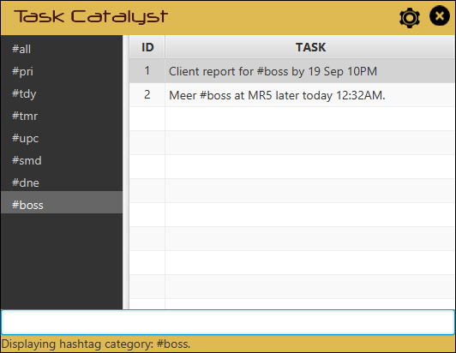

This will display the corresponding items with the hashtag. Notice that the selected hashtag is highlighted.

Searching for Tasks
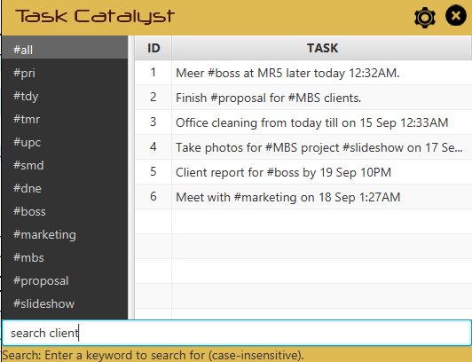
You can also search for tasks typing “search”, or alternative commands, followed by a search string.

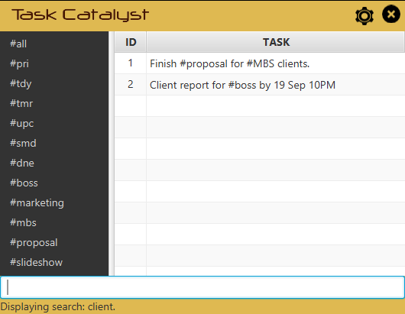
Matching items are quickly displayed in the task view.

Editing a Task
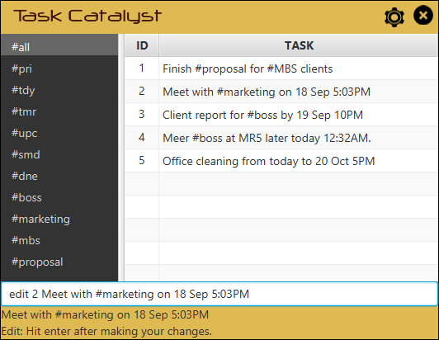
You edit a task simply by typing “edit”, or alternative commands, followed by the task number.

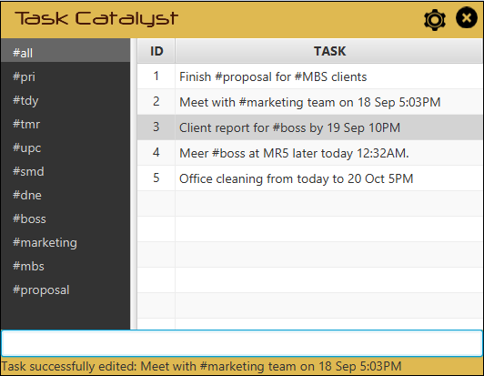
This will move your cursor focus to the task where you can make your changes. Simply hit ENTER to save the changes.

Completing a Task
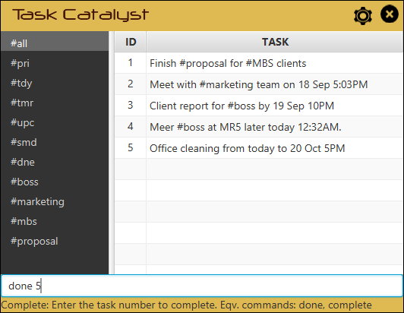
You can complete a task simply by typing “done”, or alternative commands, followed by the task number.

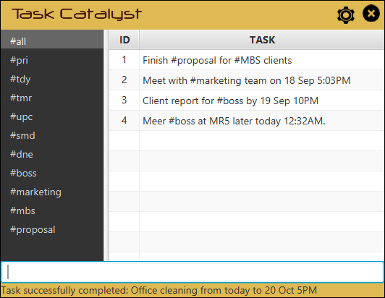
The specified task is moved into the #done list and will no longer show up in other categories.

Deleting a Task
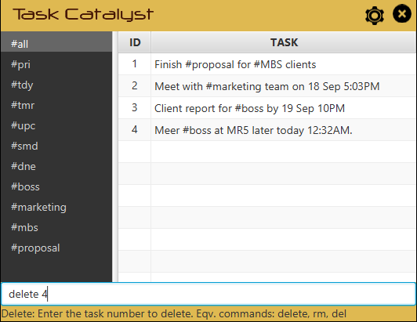
You can delete an unwanted task simply by typing “delete”, or alternative commands, followed by the task number.

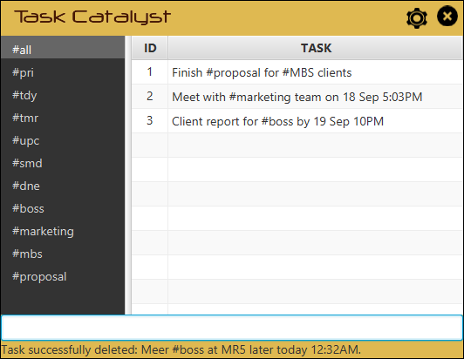
The item is deleted and removed from view.

Undoing an Action
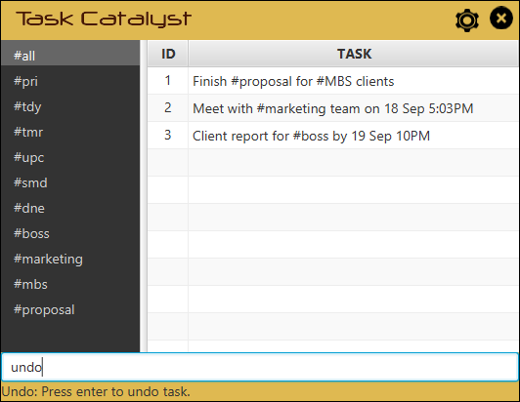
You may undo an action by typing “undo”, or alternative commands.

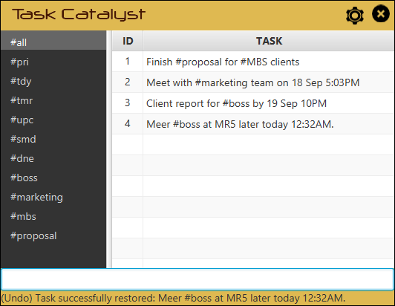
The previous action is undone. You may also redo by typing “redo”.

Setting Priority
You can set priority by hashtagging an entry with #*. The item specified will be marked with a graphical star in the list view. For example:
Meet #boss at MR5 later today. #*

Adding Reminders
You may also specify reminders by using a pipe (“|”) followed by the time and an optional date. For example:
Meet #boss at MR5 later today. | 15:00
If no date is specified, then the reminder would be set for the particular date the entry is due.

Hotkey Summoning
You will be able to summon the program using a user-defined global hotkey you set from the settings page. We will introduce this feature later on in the program.

Smart Paste
You will be able to quickly paste highlighted text from other applications using a user-defined global hotkey. We will also introduce this feature later on in the program.
Appendix A: User stories.

Likely
ID | I can … (i.e. Functionality) | so that I … (i.e. Value)
Basic Add | I can add tasks to the program | so that the program can manage my TODO for me.
Date and/or Time | I can specify date and/or time when adding tasks, | so that I can keep track of the tasks.
Display Tasks Chronologically | I can view tasks in chronological order, | so that I know the upcoming tasks.
Mark As Done | I can mark tasks that are done, | so that I can view the outstanding tasks.
Edit Tasks | I can edit my tasks, | so that I can make changes where necessary.
Delete Tasks | I can delete a task
Undo / Redo | I can undo or redo an action, | so that I can revert any unwanted changes.
Alternative Commands | I can make use of different keywords to represent the same command, | so that I can use what's most natural to me.
Date Range | I can specify a date range for my tasks, | so that I do not have to add multiple tasks to cover the range.
Deadline Categories | I can view tasks that are sorted into different deadline categories (today, tomorrow, upcoming), | so that I can better organize my tasks.
Hashtag Marking | I can make use of hashtags, | so that I can mark important keywords.
Hashtag Retrieve | I can retrieve tasks marked by a hashtag, | so that I can view related tasks.
View Done History | I can view my task history, | so that I can review what I've completed.
Flexible Date/Time Format | I can use many different formats for date and time, | so that I can use what is natural to me.
Overlap Notification | I am notified when I have overlapping tasks, | so that I know if I need to reschedule tasks.
Priority | I can set priority to tasks, | so I know what to do first.
Reminder | I can set reminders for tasks, | so that I will not miss my appointments.
Delete/Done Multiple Tasks | I can select multiple tasks to delete or complete, | so that it will speed up my workflow.
Shortcut Keys to Summon | I can make use of global shortcut keys to summon the program, | so that I do not have to use the mouse for that.
Shortcut Keys to Paste | I can quickly add items from another application (i.e. Email Client, Web Browser) into my TODO using hotkeys, | so that it speeds up my workflow.

Unlikely
ID | I can … (i.e. Functionality) | so that I … (i.e. Value)
Email Notification | I receive notifications for reminders via email, | so that I will be notified on the go.
Google Calendar Integration | As a user, I can view and edit the tasks in Google Calendar, | so that I can manage my TODO on other computers using a web-browser.

Appendix B: Product survey
Product: Any.do Documented by: Ang Kah Min, Kelvin

Strengths:
- Very simple workflow if we are just using it to manage our tasks. (Add task into command bar, then complete tasks by swiping.)
- Tasks are added as they are with minimal parsing and processing.
- Automatic categorization based on date (Today, Tomorrow, Upcoming, Someday, etc.).
- Synchronization with central server so tasks are accessible on any device.
- Optimized for touch interface.
Weaknesses:
- Contains many advanced features most people will not use.
- Any.do moments, their daily planning feature, can be too flashy and slow.
- Autocomplete transmit task details to the web, possibly leading to privacy issues.
- Quite difficult to delete tasks.
- Folders feature badly implemented. Very impractical to use.
Product: Remember the Milk Documented by: Toh Zhen Yu

Strengths:
- There’s user login feature which enables user to login through their web browser or phone
- Able to sync from phone to other devices.
- Able to collaborate with google calendar.
Weaknesses:
- Unable to add task that’s beyond 7 days.
- There’s no command line interface, have to use mouse to navigate the interface.
- There’s no desktop version of this product, only can access through internet. Without internet access, you can’t view your task.
Product: Todoist Documented by: Thida

Strengths:
- Simplicity in work flow, features are easy to manage task by using shortcut or clicking (add task into command bar, done task by ticking on task, set priority)
- Flexible format for adding date including recurring date
- Sorting by date, priority and name
- Automotive categorize by day (today, next 7 days), projects (personal, work or any preferred types that can be added on) and labels
- Notification through email for a summary of task on a day
- Synchronization can be any device and platform
Weaknesses:
- The display for “today” does not show only today tasks (included uncompleted tasks)
- Bulk processing features in general are weak (remove a due date, assign/remove a label and assign/change/remove priority)
- Recurring tasks are available only by typing the natural language syntax (not support for mobile version)
Product: Wunderlist Documented by: Lim Wei Jie

Strengths:
- Relatively easy to add, edit and delete tasks.
- There is a reminder function to set the time when you will receive a notification.
- Able to mark a task as done and it will stay within completed tasks column.
- Easy to set the important task by tapping the star icon on the right of a task.
- There is a share function to share a list of tasks with family or friends.
Weaknesses:
- There is no undo function to undo the action that has been accidentally made.
- There are no multiple notifications for recurring tasks.

